The architecture pattern we choose is Client-Server. As a client, go to the sign in screen and due to the different position: owner of employee, User may go to different screens. As owners, they will have two more options, account settings and create new account. When user go to general sales prediction, it will connect to the server and get the data from database

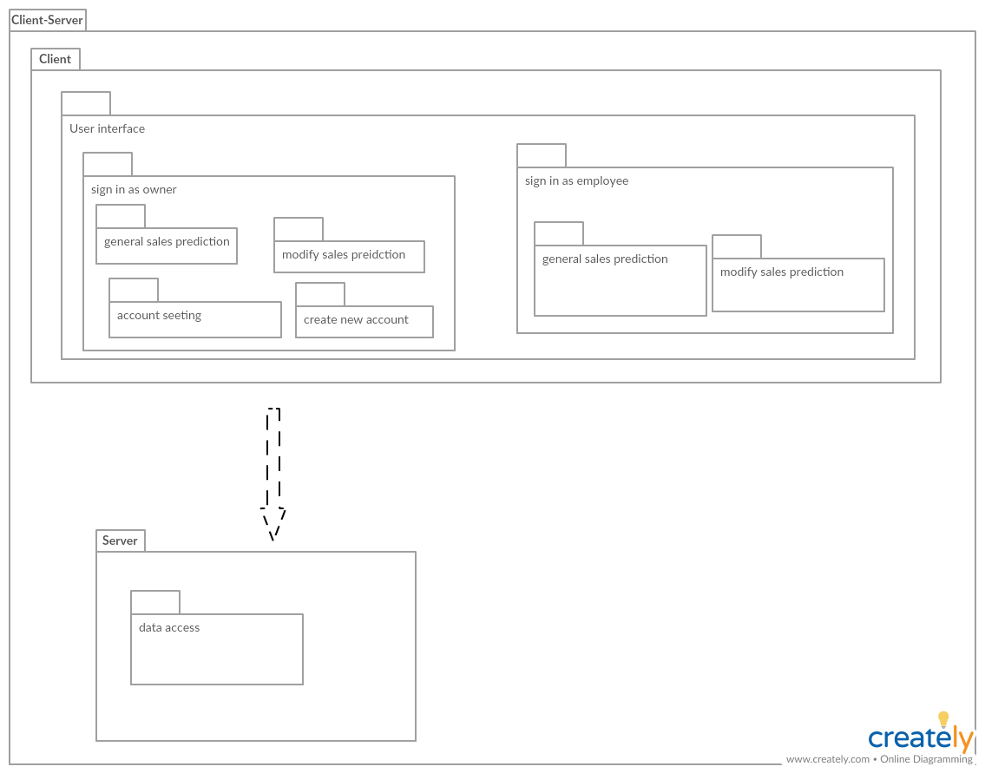

Design pattern

We do not use design pattern